
Here are the long awaited results of the Village Survey. These were going to be presented at the Village Fayre as nice big posters along with a lot of other information about the new Community Centre. I have done my best to fit the results on one page! If you want to see the originals go to www.planetx.org.uk/hdcc and you can download. - John Thompson
Of those who answered: Playing Field 47.8%, Existing site 32.7%, Undecided 19.5%
You were asked to tick activities that you would interested in doing:-
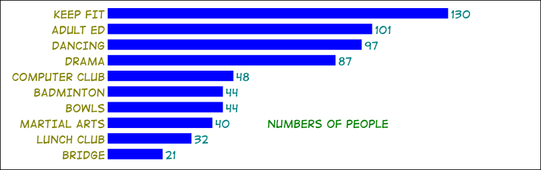
Here are the results from the other questions (some non committal so totals not 100%):-
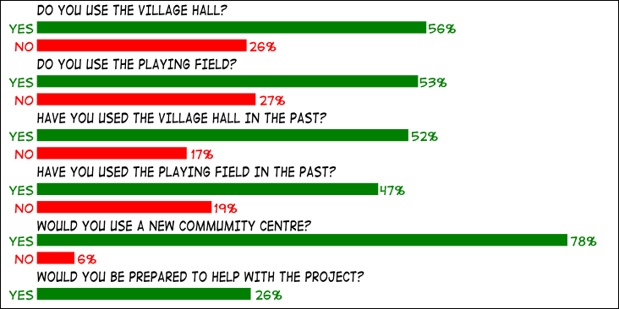
Please turn to read our second page – we need your help, please!

